Version：1130045 GM75M2

**Shanghai Goodview Electronics Technology Co. Ltd.**

# 75-inch Large Size Commercial Display

**Model: GM75M2**

**Revision History**

|  |  |  |  |  |  |  |
| --- | --- | --- | --- | --- | --- | --- |
| **Part number** | **Version** | **Publish date** | **Written by** | **Auditing** | **Approval** | **Remarks** |
| 1130045 | GM75M2-GGS20190705 | 2019\07\04 |  |  |  |  |
|  |  |  |  |  |  |  |

**Note**：All right reserved by Goodview.Please contact with us for the latest updates.

## Product Specifications

|  |  |
| --- | --- |
| **Display** | |
| Panel | 75 inches LED backlight |
| Active Area(mm) | 1649.664(H) ×927.936(V) |
| Aspect Ratio | 16:9 |
| Resolution | 3840×2160 |
| Brightness | 300cd/m2 |
| Contrast Ratio | 1100:1 |
| Viewing Angle | ( R/L 89 (Min.), U/D 89 (Min.)) |
| Display Colors | 1.07G colors (10-bit) |
| Color temperature | / |
| Life Expectancy | 30000 hours |
| Response time | 8ms |
| **System configuration** | |
| CPU | ARM A53×4 1.5GHz |
| GPU | ARM Mali T720mp2 |
| Memory | 2G |
| Storage | 16G |
| Operating system | Windows 10(OPS computer)&Android6.0 |
| **Touch** | |
| Model | / |
| Touch point | / |
| Touch type | / |
| Touch precision | / |
| Touch resolution | / |
| Response time | / |
| Input mode | / |
| Smallest touch objects | Single: /  Multipoint: / |
| External ports | |  |
| Signal ports | HDMI IN×2、 AUDIO OUT×1 、HDMI OUT×1 |
| Network ports | LAN、WIFI（IEEE802.11ac 2.4GHz/5GHz） |
| Storage extension | SD Card 64GB (Max) |
| Other ports | AC IN×1、USB（2.0）×4、RS232（RJ45）×1、TF CARD×1 |
| Multimedia | |
| media file formats | Video：MPEG1、MPEG2、MPEG4、H.264、WMV、MKV、TS、flv and other mainstream video formats |
| audio: MP3 and other audio formats. |
| picture: JPG、JPEG、BMP、PNG、GIF |
| text：txt |
| Others：/ |
| Play mode | Horizontal screen, Vertical screen, Full screen |
| Program transmission mode | USB |
| Machine parameters | |
| Product size (mm) | 1694.24 (H)×971.96 (V)×60.90(D) |
| Carton size（mm） | 1835 (H)×1102 (V)×215 (D) |
| VESA (mm) | 600*600/600*800 |
| Screen suspension mode | Landscape, Portrait, Freestanding mount |
| Menu language | Chinese, English |
| Machine color | black |
| Weight | net： KG gross：KG |
| Power consumption | 320 W |
| Speaker | 2.1 Stereo 2×10W 4Ω+15W 4Ω |
| Smart volume | / |
| Watchdog function | / |
| Timing | / |
| Management software | / |
| Power supply | AC~100-240V (50/60Hz) |
| Working environment | 0〜40℃ 10% 〜 85%RH No condensation |
| Storage environment | -10〜60℃ 10% 〜 90%RH No condensation |
| Accessories | 1. Remote control x1 2. AC power cable x1(standard) 3. AAA batteryx2 |
| Certificates | CCC/CE/UL/ETL |

## Schematic Drawing

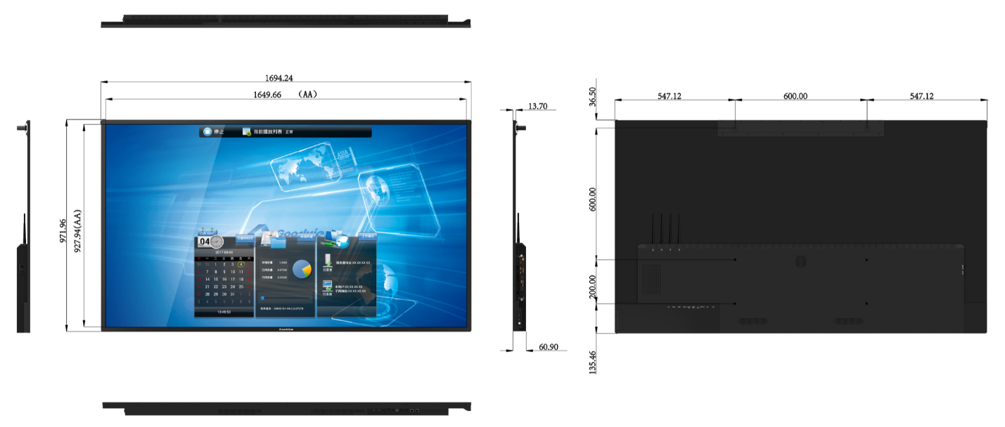

## Product Images

## 

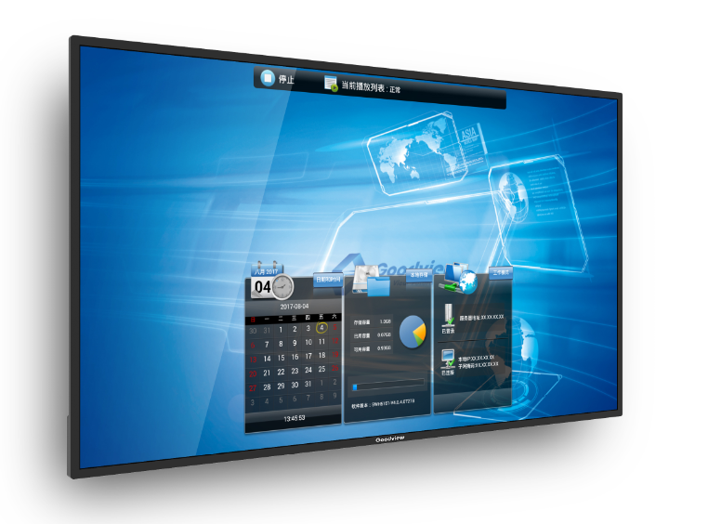

## 

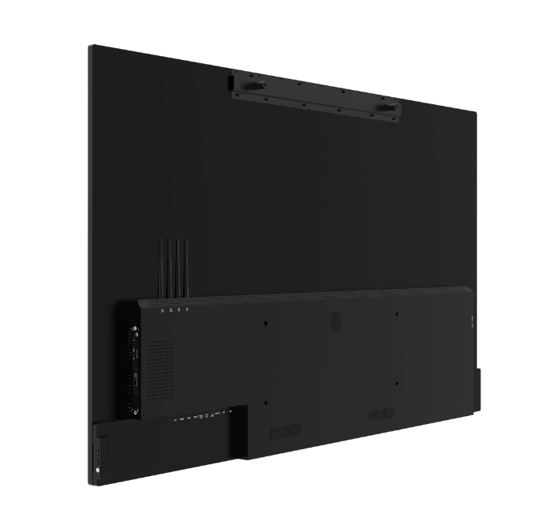

## 

## 

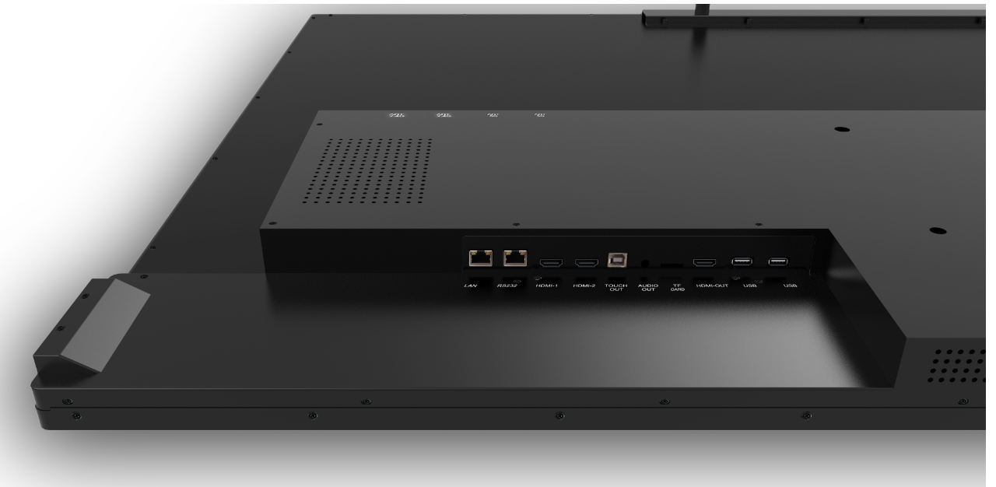

## Packaging

1835 (H)×1102 (V)×215 (D)MM

**Note**：All right reserved by Goodview.Please contact with us for the latest updates.